LAB SHEET 8: Self-Balancing & Multi-way Search Trees
- Syllabus Reference: Unit 8 (Lab Manual)
- Target Concepts: BST constraints, balance factors, multi-way node insertion rules.
Objectives
Implement search tracking constraints that maintain efficient search bounds under dynamic updates.
Tasks
- BST Operations: Write a standard Binary Search Tree supporting element insertion and ordered deletion.
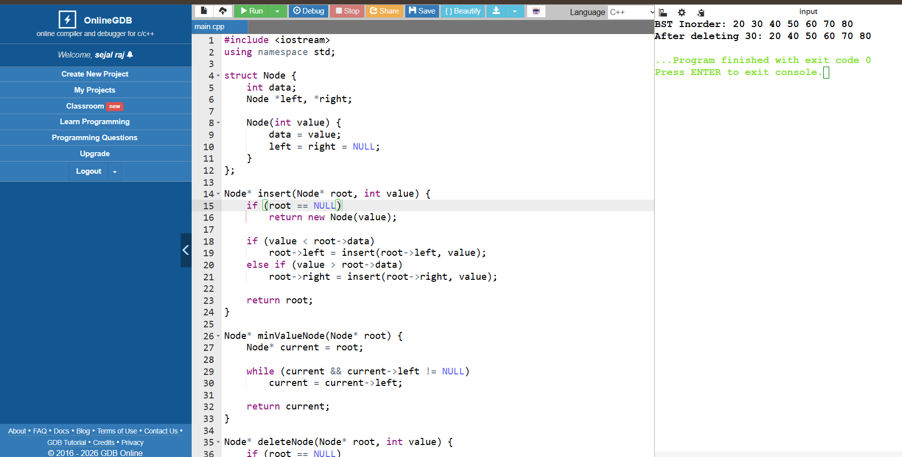
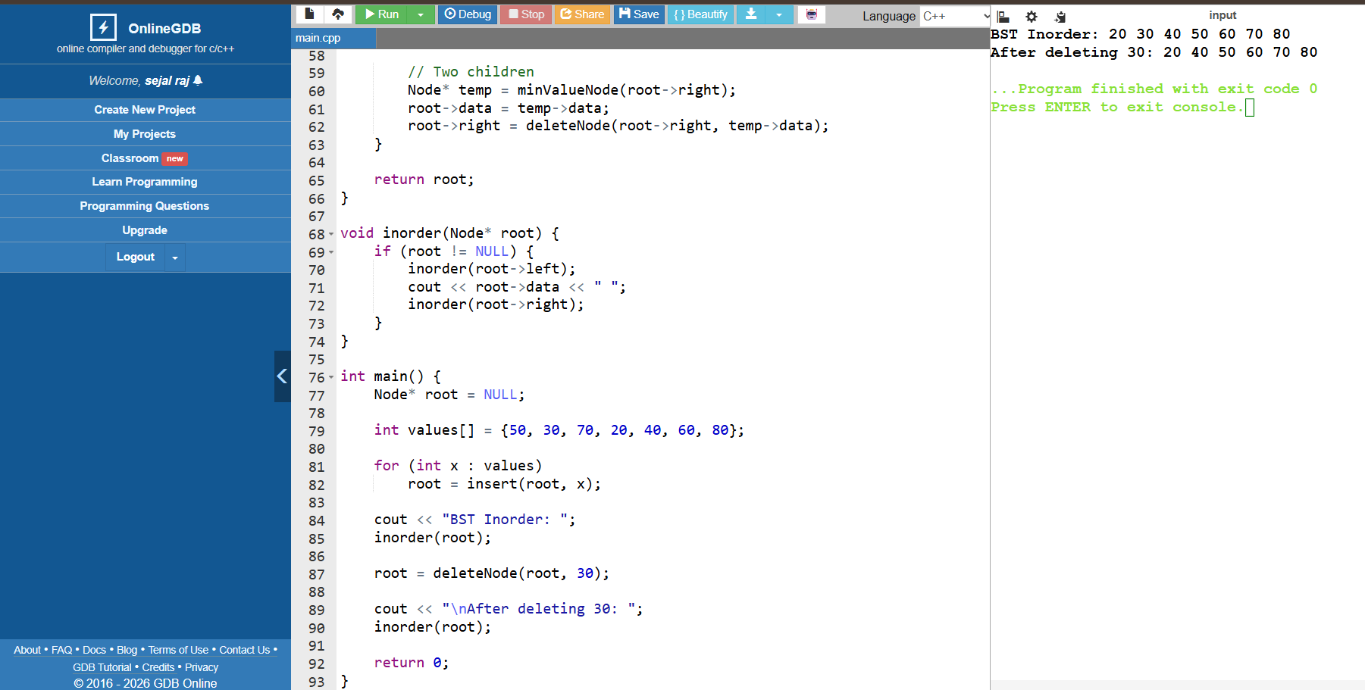
- AVL Tree Rotations: Implement an AVL insertion tracker that monitors balance factors and executes single or double transformations ($LL, RR, LR, RL$) when a node becomes unbalanced.
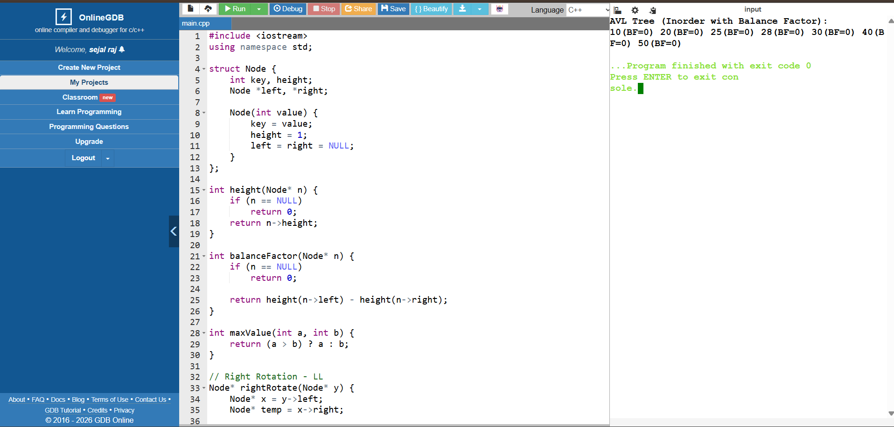
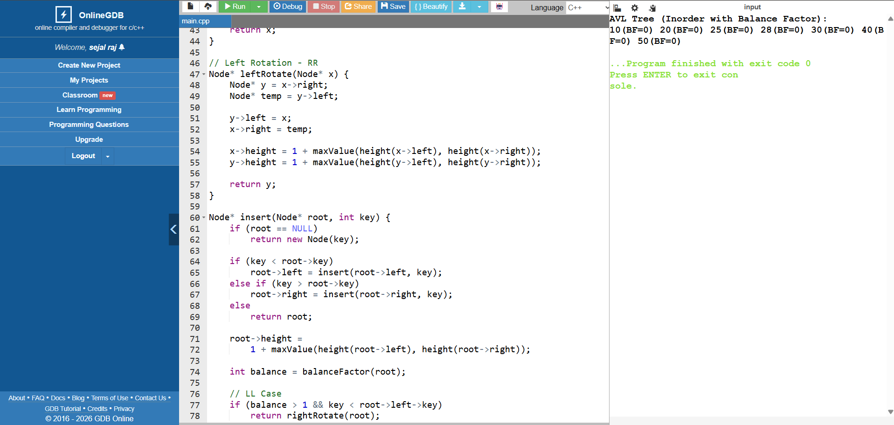
- B-Tree Insertion Simulator: Write a mock framework managing basic item additions inside an order-3 ($M=3$) B-Tree node layout, handling node splitting when capacity is exceeded.

